

**CR A IVl CORN**

O_u_n_ti-tl-ed _

**ISHWA**

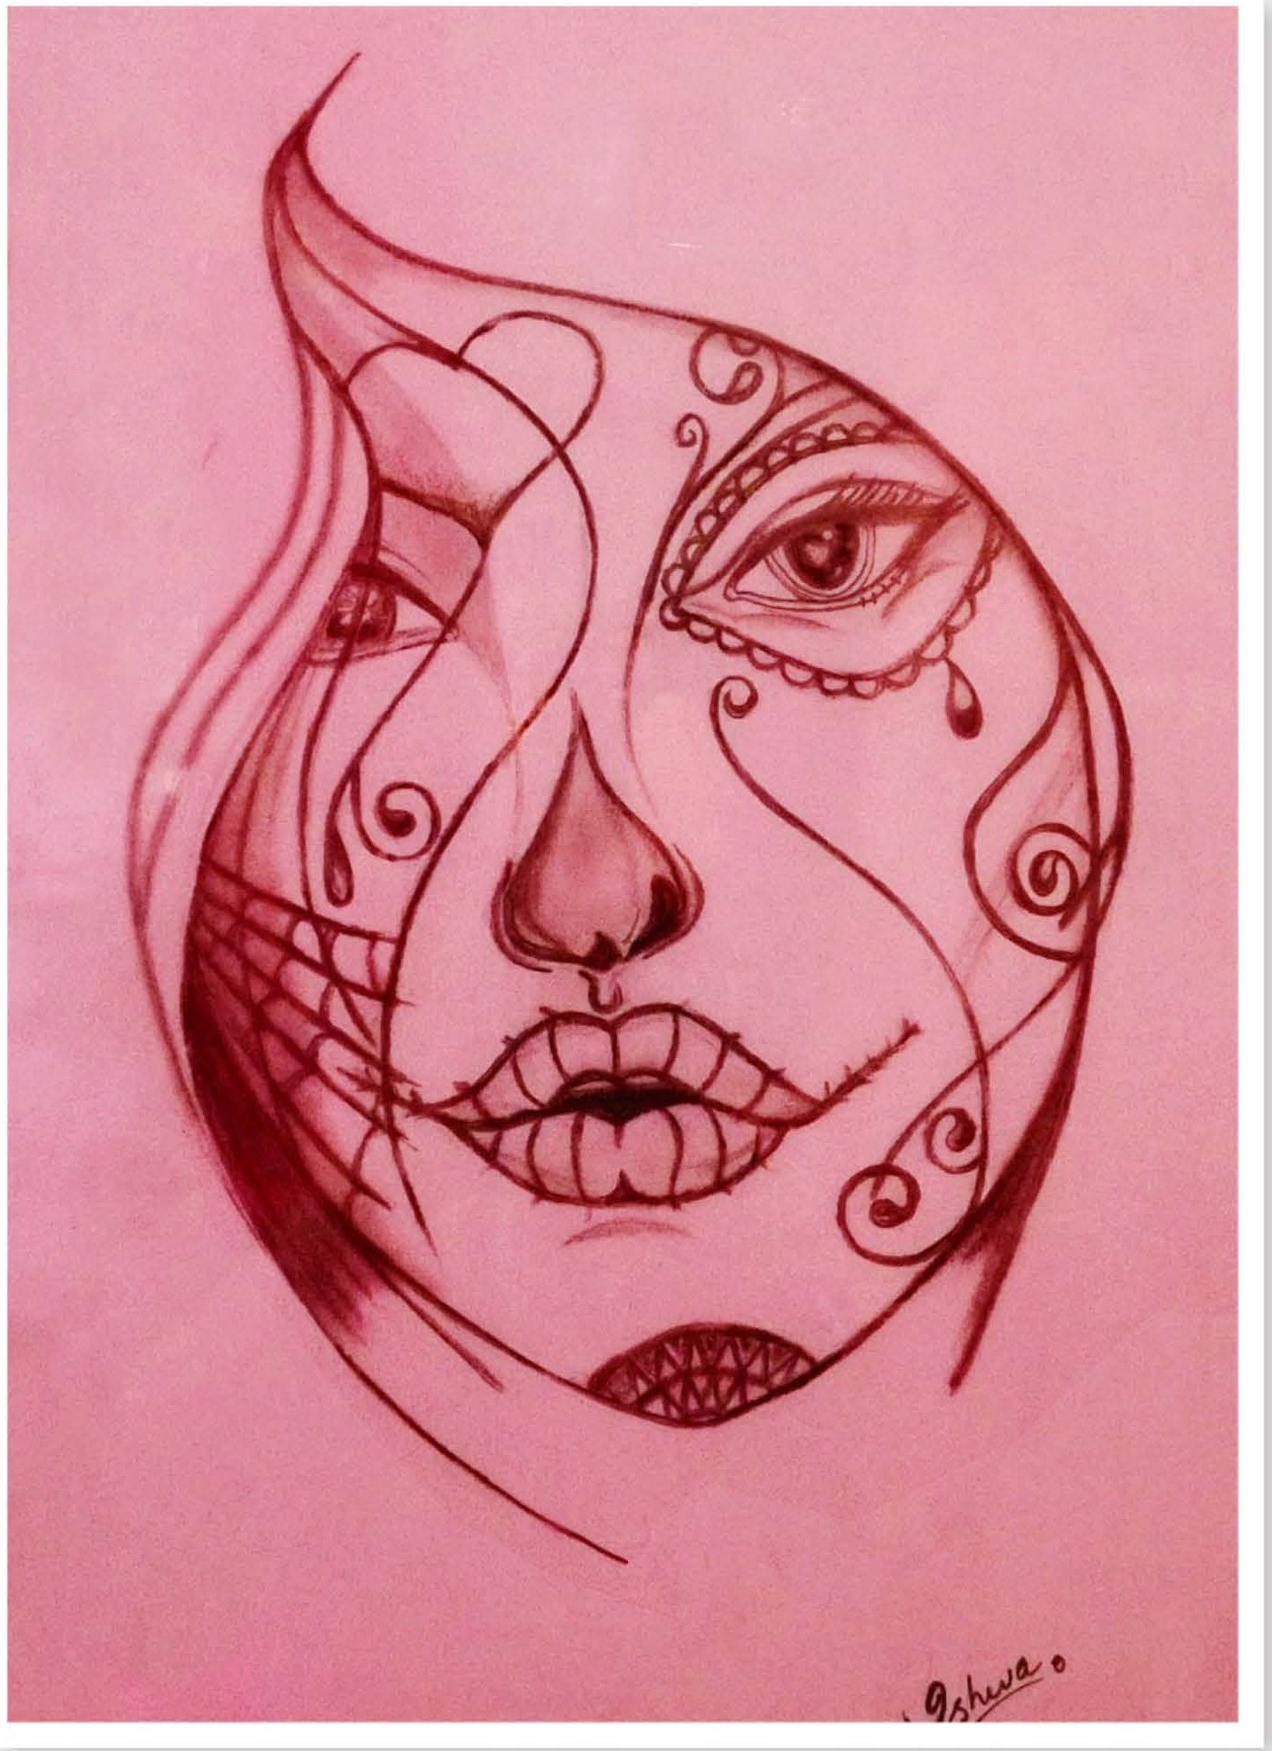

The image depicts the inner emotional world of a depressed individual. How a depressed person views his or her life and how he or she experiences him or her self. The shape of tear symbolized that the core of the illness is being gloomy.

*OCTOBER-DECEMBER 2016* I *VOLUME 13 NUMBER 4 PAGE43*